BARANI INSTITUTE OF INFORMATION & TECHNOLOGY

ADVANCE DATABASE

PROJECT REPORT

JEWELRY SHOP MANAGEMENT SYSTEM

BSCS 5A

Submitted By

Ayesha Bibi

2024-arid-0058

Submitted To

SIR HAMMAD

Home Screen:
It’s a welcome screen where user can navigate to any other page as well and also can get knowledge about the shop, and can login & signup.
In short, This is the main landing screen of my system.
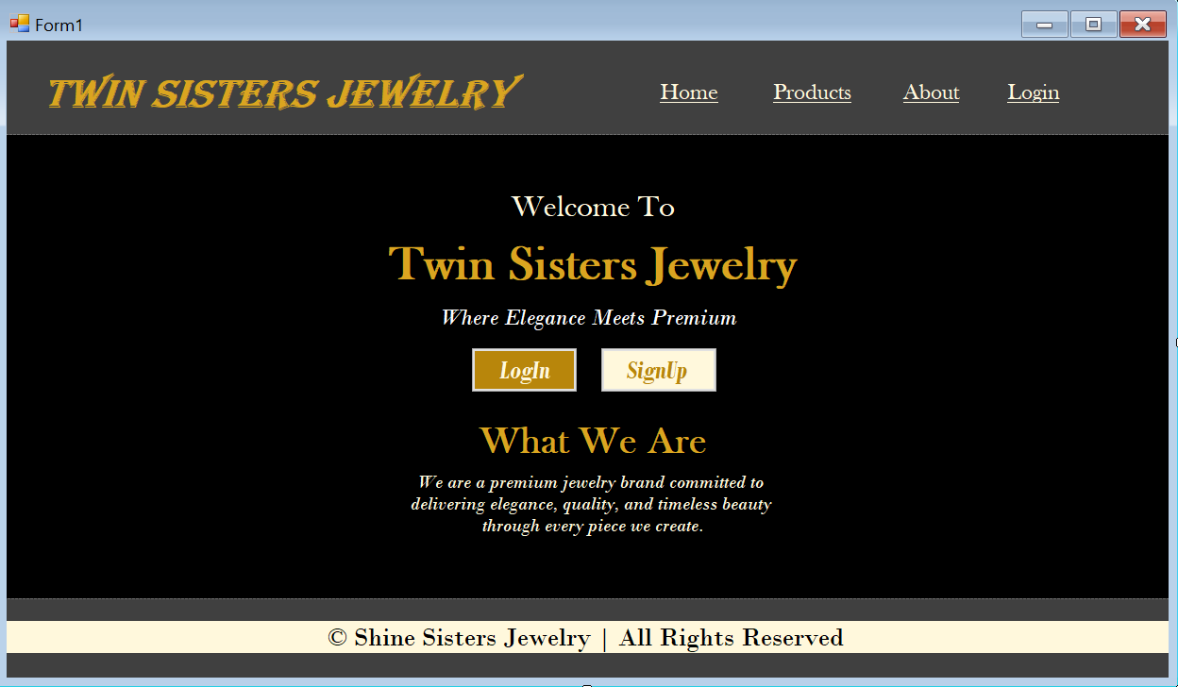Signup Screen:
It’s a Signup screen where user will enter his details to sign up and record will save into databse on click of submit button
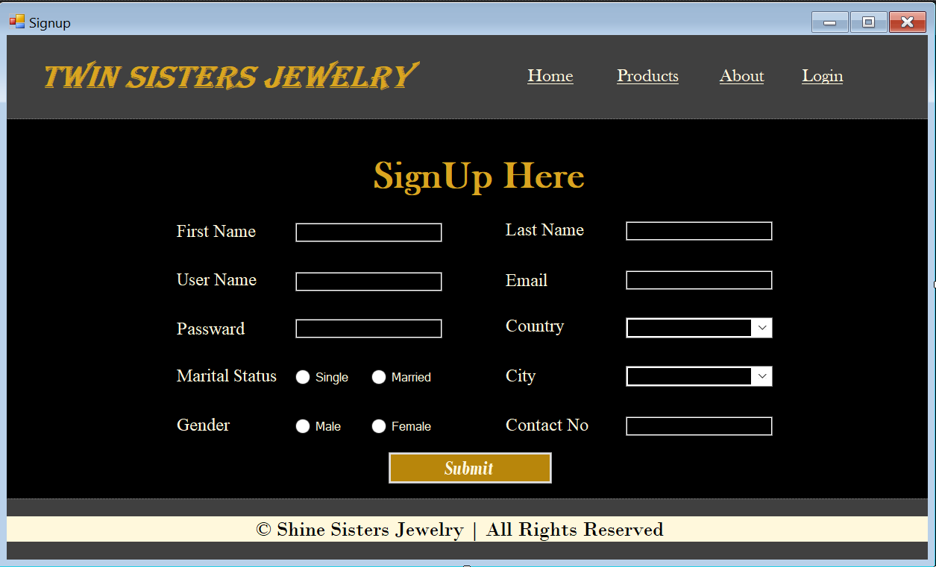
Login Screen:
It’s a Login screen where user will enter his credentials to login and record will be checked into database on click of login button.
If record will exist Login Successful, Else Will show notification box User doesn’t exist.
On forget Passward: It Will ask for User name and then will fetch passward stored in DB against this username to the screen.
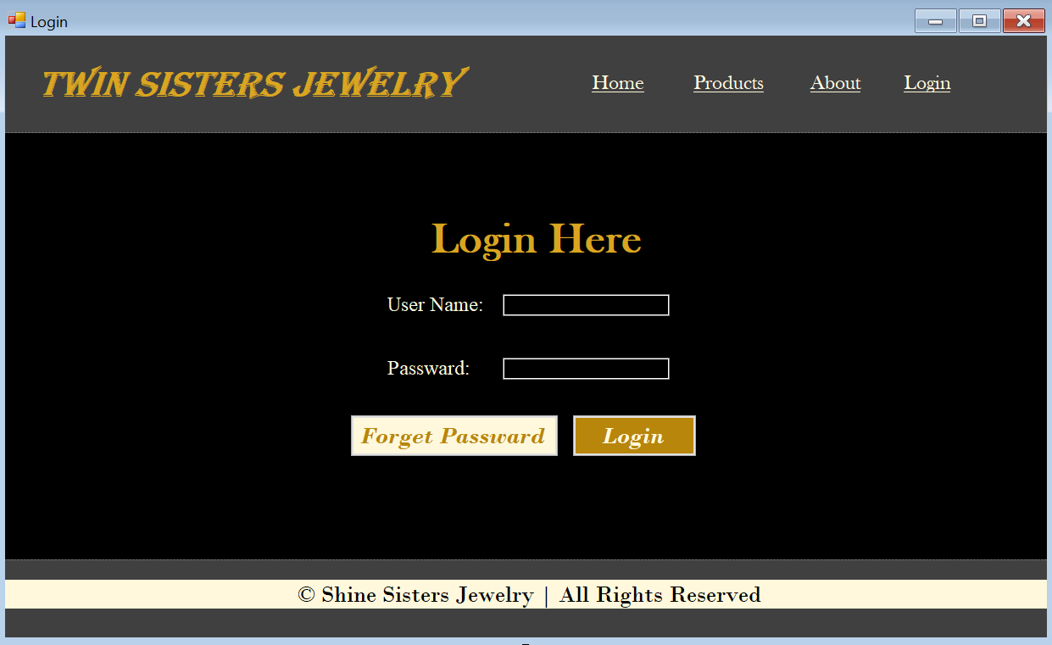
Jewelry Management Screen:
It’s a Jewelry Management Screen where admin will enter details of items and record will be saved into database on click of add new item button.
On click of View New List the data will fetch from database and will show into grid view. On click of Edit Item it will take id and on the basis of that id record will be edited and same for Delete item as well.
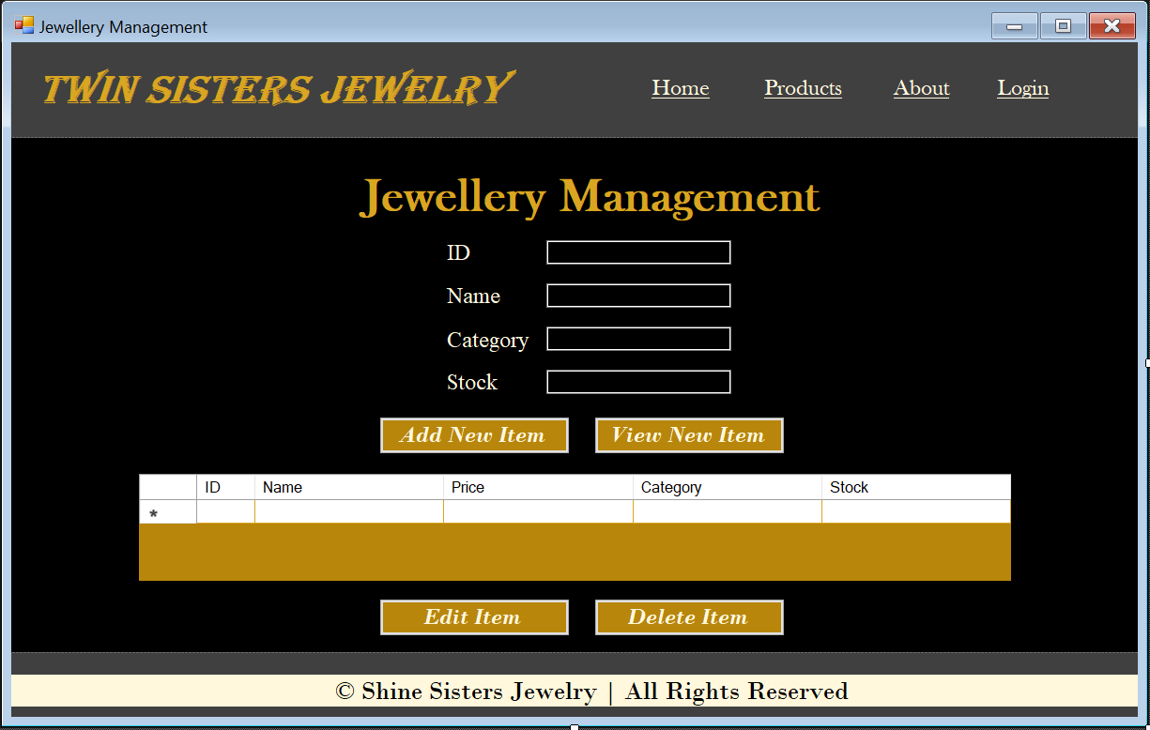
Customer Management Screen:
It’s a Customer Management Screen where admin will enter details of Customer and record will be saved into database on click of add Customer Details button.
On click of View Customer Details the data will fetch from database and will show into grid view. On click of Edit Details it will take id and on the basis of that id record will be edited and same for Delete Details as well.
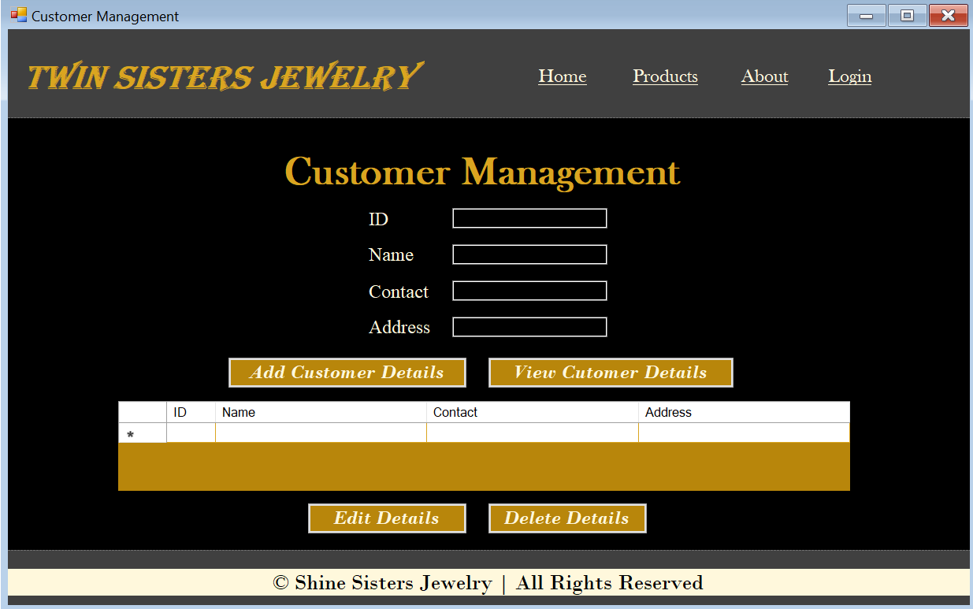
Inventory Management Screen:
It’s a inventory Management Screen where admin will enter search item on the basis of his own search criteria. He/she will enter Item Name to search and then In Filter there are three options will give All/Low Stock/Available on the basis of this filter record will fetch from database and dispayed in grid view
On click of Update stock the stock will updated, it will take id of item and on the basis of that id record will be edited if there is any sale against that item happened or more stock added.
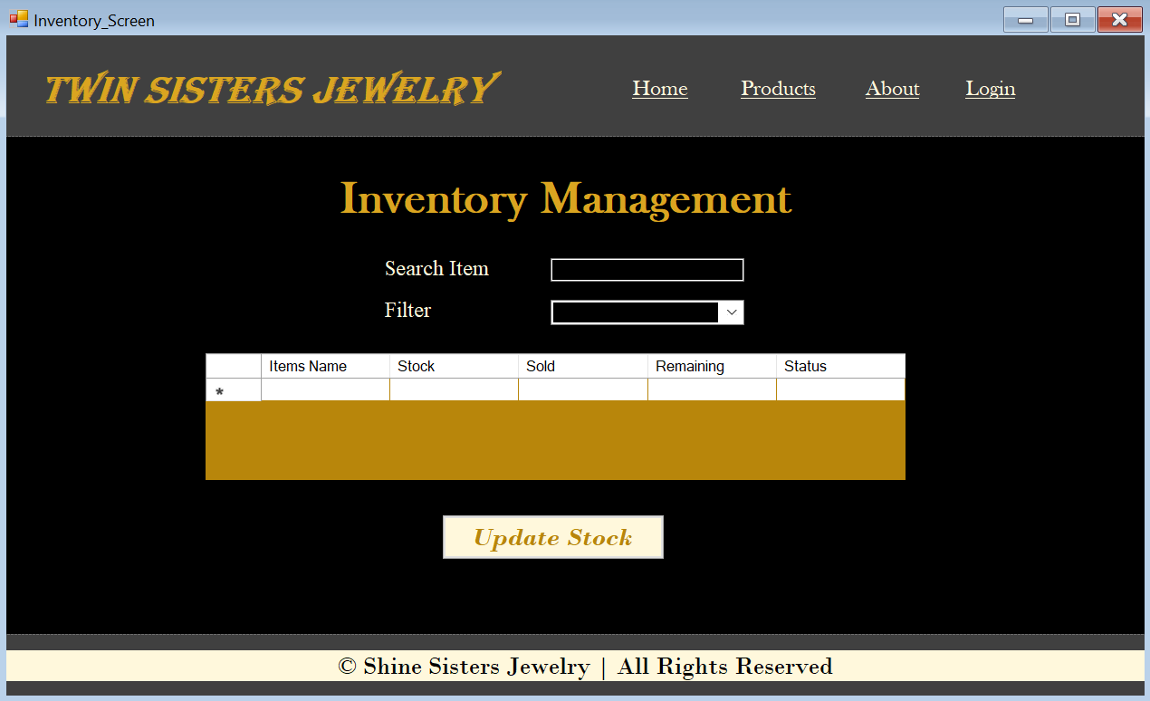
Selling & Billing Management Screen:
It’s a Sales & Billing Screen where the admin will manage the complete selling process of jewelry items.
On clicking Add to Bill, the selected item along with its quantity and price will be added to the billing section (grid view). Multiple items can be added in the same way to generate a complete bill.
The system will automatically calculate the total amount based on selected items and their quantities.
On clicking Generate Invoice / Finalize Sale, the sale will be completed and stored in the database.
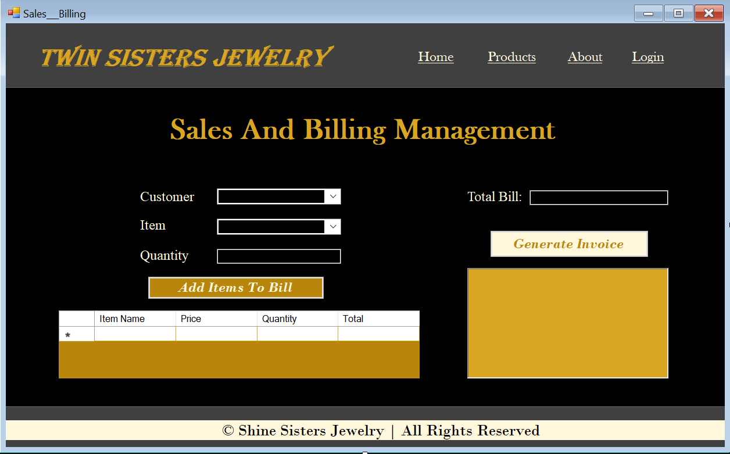
Sales report Screen:
It’s a Sales Report Screen where the admin can view and analyze all the sales data of the jewelry shop. User will select a date range or specific date to view sales records. Based on this selection, the system will fetch sales data from the database and display it in a grid view.


